CSI2441 Assignment 2: Marking Key

Student ID: 10371381

Student Name: Martin Ponce

FUNCTIONS
Criteria | Mark Weighting
1) Manage Students, Units and Course Details (add, edit, delete, validation of allowable inputs) | 11 / 12
3) Manage and Display Student Results (search and browse options, automatic credit point calculation, course status, unit results, validation of allowable inputs) | 8 / 10
5) Implementation of Unexpected Scope Change | 3 / 3

Overall Summary
Martin

Overall this was a professionally presented, highly functional assignment, but I did notice something strange when editing results. Melissa Masters was set as ‘Completed’ so I went in and edited two or her units to see if the value changed from Completed to Enrolled – but what actually happened is that both the units I edited simply disappeared from her results – and she was still listed as Completed.

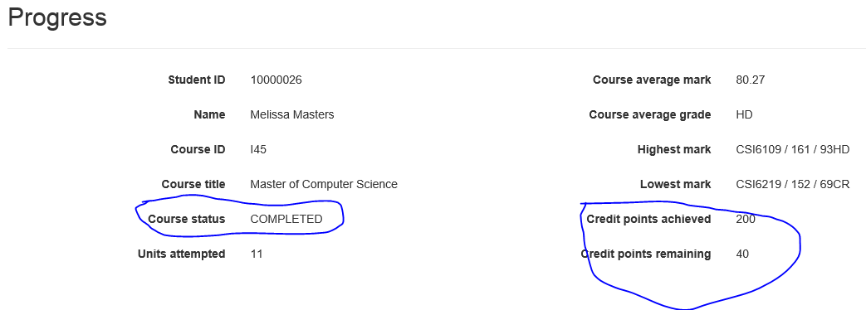

However, aside from that I found nearly all of your other features worked extremely well – especially your absolutely first-rate client and server side validation – well done.

Total Mark 23 / 25
Assignment Grade __HD___

